**American International University-Bangladesh (AIUB)**

**Department of Computer Engineering**

COE 3201: Data Communication Laboratory

**Lab Report 7**

**Title: Study of Frequency Modulation and Demodulation using Simulink (MATLAB)**

**Supervised By**

**SADMAN SHAHRIAR ALAM**

## Submitted By

|  |  |
| --- | --- |
| **Name** | **ID** |
| **RIFAH SANZIDA** | **22-47154-1** |

## Group Members

|  |  |
| --- | --- |
| **Name** | **ID** |
| **MD. JOBAER HOSSAIN** | **22-47116-1** |
| **MD SAMIN YEASAR** | **22-47139-1** |
| **SHAYAN ABRAR** | **22-47156-1** |

**Abstract:**

This experiment is designed to-

1. To understand the use of Simulink for solving communication engineering problems.
2. To develop understanding of Frequency Modulation and Demodulation using Simulink.

**Theory:**

To learn this, and experiment properly one should first go through the below concepts for a better understanding**.** In terms of message signal transmission using carrier waves**,** Frequency Modulation (FM) is one of the conventional techniques. The amplitude or strength of the high-frequency carrier wave is modified in accordance with the frequency of the message signal.

The angle-modulated signal described in the time domain:

𝑠(𝑡)=𝐴𝑐cos[2𝜋𝑓𝑐𝑡+𝜃(𝑡)] =𝑅𝑒{𝐴∗exp(𝑗𝜙(𝑡))}

The modulated signal 𝑠(𝑡) is: 𝑑𝑠(𝑡)𝑑𝑡=−𝐴𝑐[2𝜋𝑓𝑐+𝐾𝑓𝑚(𝑡)] 𝑠𝑖𝑛(2𝜋𝑓𝑐𝑡+2𝜋𝐾𝑓∫𝑚(𝜆)𝑑𝜆𝑡−∞)

The differentiated signal is both amplitude and frequency modulated, the envelope

𝐴𝑐[2𝜋𝑓𝑐+𝐾𝑓𝑚(𝑡)] is linearly related to message signal (amplitude component) and

𝑠𝑖𝑛(2𝜋𝑓𝑐𝑡+2𝜋𝐾𝑓∫𝑚(𝜆)𝑑𝜆𝑡−∞) is a high-frequency component. Therefore, (𝑡) can be recovered by

an envelope detection of 𝑑(𝑡)𝑑𝑡.

**Frequency modulation :**

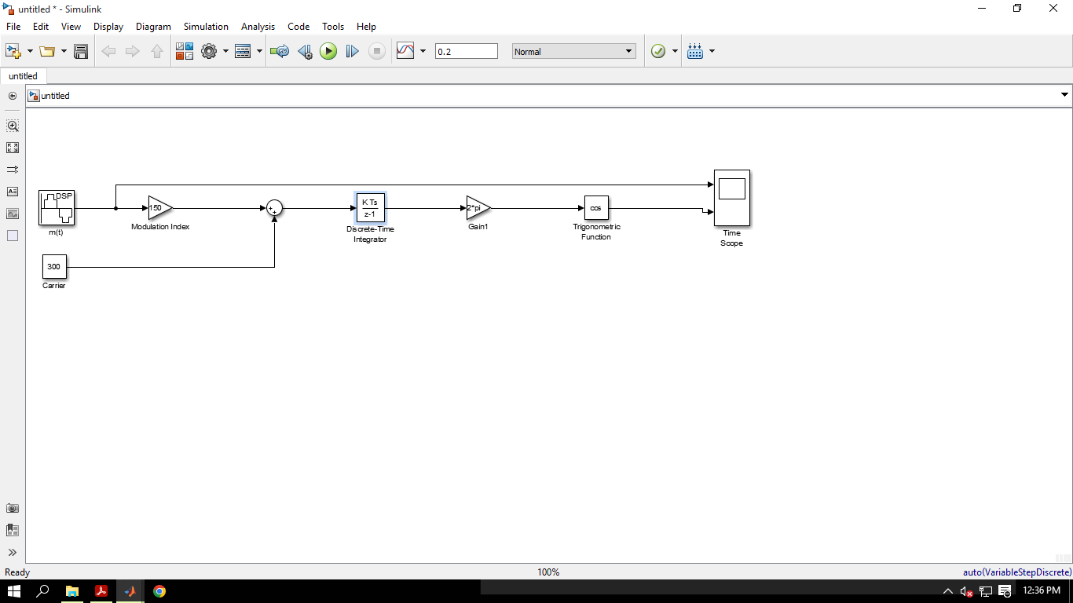

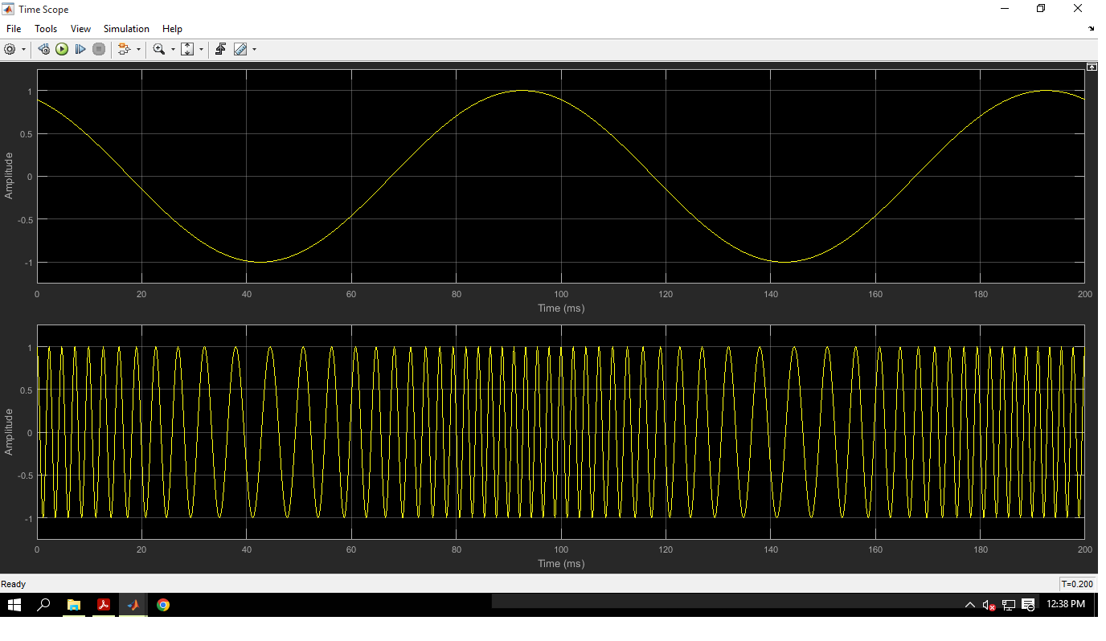

**Figure: FM modulation**

**Frequency modulation and demodulation:**

**Figure: FM modulation and demodulation**

**Discussion and Conclusion:**

The desired result was obtained after successfully completing the lab work. Each segment answered as required. But the proper result didn’t come on the first try. By changing, function values correct result is obtained gradually.Simulink environment, commands, and syntax are now a clear concept after completing the experiment. From now FM Modulation problems can be solved effectively.

## References:

1. M. P. Fitz, Fundamentals of Communications Systems, pp. 7.1-7.7, 2007, McGraw-Hill
2. MathWorks®, Voltage Controlled Oscillator.